BASIC NETWORKING SKILLS FOR DIGITAL FORENSICS
AKINWA OMOKUNLE ANTHONY
2025/FWSD/11206
HTTP ANALYSIS USING WIRESHARK - EMBEDDED IMAGE TRAFFIC
AMINU IDRIS
08/08/2026

EXECUTIVE SUMMARY
This laboratory focused on the forensic analysis of embedded image traffic transmitted over plaintext HTTP. A local Apache web server was used to host a webpage containing an embedded image, while Wireshark/TShark was used to capture and analyze the network traffic. The investigation examined the HTTP requests and responses generated by the browser, TCP segmentation and reassembly, and the extraction of the transferred image from the packet capture. SHA-256 hashing was also used to compare the original image with the extracted image and assess evidence integrity.
OBJECTIVES
During the investigation, the browser generated separate HTTP requests for the webpage and the embedded image. The HTTP responses showed successful delivery of the requested resources. The image data was transferred through TCP and could be divided across multiple TCP segments before being reassembled into the complete HTTP object. The image was successfully extracted from the packet capture using Wireshark Export Objects/TShark. The original and extracted image were then compared using their file properties and SHA-256 hashes.
TOOLS USED AND RESOUCES
The tool to be used when it comes to offensive security lab project environment, we will be using several tools which are: Kali Linux, Apache2, Wireshark, TShark, CURL, SHA-256, Linux command line, Firefox , file, ImageMagick/identify

METHODOLOGY
In this methodology, I am going to solved the assignment using part, step and we will be setting up our forensic workspace
Lab Folder Struture and Evidence Preparation
Step 1A: Create the lab folder structure
In this step, we will be creating the lab folder structure
mkdir -p ~/SBT-DF203-Lab2/{evidence,working,exported,reports,screenshots,scripts}
cd ~/SBT-DF203-Lab2
pwd
find . -maxdepth 1 -type d -print
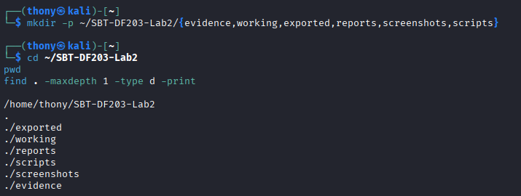

Step 2: Installing required update tools
In this step, we will be making sure that our system is up to date using the following command below.
sudo apt update
sudo apt install -y apache2 curl wireshark tshark
sudo systemctl enable --now apache2
Step 3: Create a web page
In this part, we will be downloading our image and copy it to /var/www/html and name it lab-photo.jpg after that we will be creating a web page using the following command:
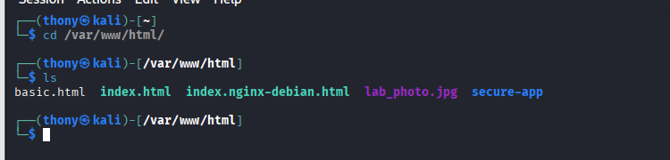
printf '<!DOCTYPE html>\n<html><body><h1>SBT-DF203 Image Traffic</h1><p>Analyst: YOUR NAME</p><img src="lab_photo.jpg" alt="Training image"></body></html>\n' | sudo tee /var/www/html/image.html
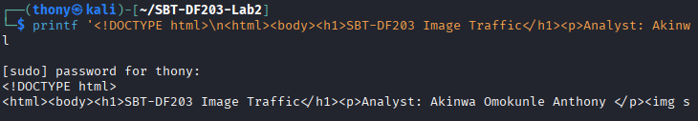
Hashes sha256sum: for both the image html and the orginal lab photo.jpg
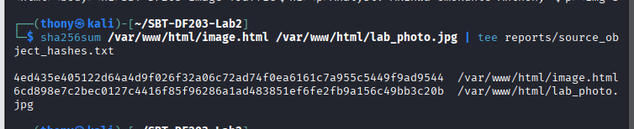
Step 3: Testing the website using curl
In this step, we will run a curl command against our webpage using our localhost interface
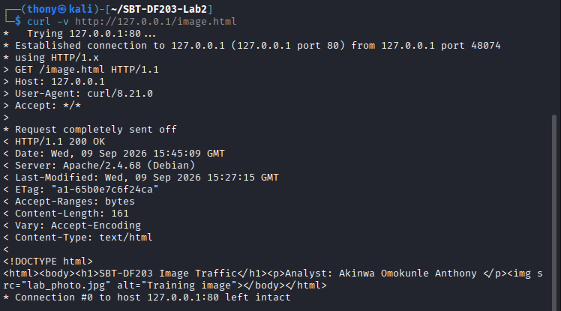
Step 4: Mini Chain of custody
Field | Student Entry
Case/lab identifier | SBT-DF203-Lab1-Akinwa Omokunle Anthony
Trainee name | Akinwa Omokunle Anthony
Date and time started | ₉th September, 2026
Evidence file name(s) | Lab_photo.jpg
Source or generation method | Local Apache capture on lo interface
Original SHA-256 | 6cd898e7c2bec0127c4416f85f96286a1ad483851ef6fe2fb9a156c49bb3c20b
Working-copy SHA-256 | 4ed435e405122d64a4d9f026f32a06c72ad74f0ea6161c7a955c5449f9ad9544
Notes on any changes | Yes, there is changes

PART A
Verify the Webpage and Eliminate Cache Effects
Use a non-sensitive image and viewing the file
In this part, we will be verifying the image file using command:
file /var/www/html/lab_photo.jpg
identify /var/www/html/lab_photo.jpg
ls -lh /var/www/html/image.html /var/www/html/lab_photo.jpg
curl -I http://127.0.0.1/image.html
curl -I http://127.0.0.1/lab_photo.jpg
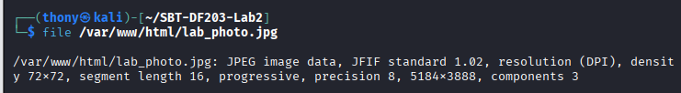
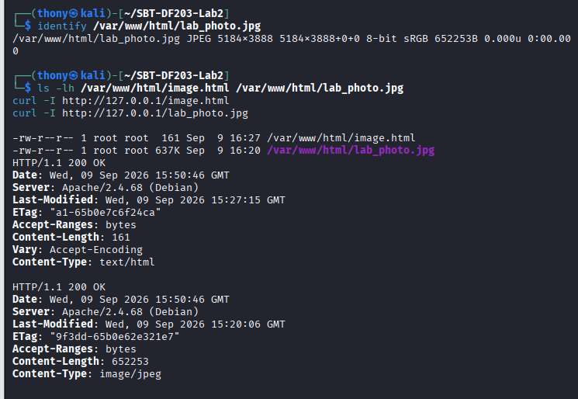

Part B
Capture Browser-Generated HTTP Traffic
Part B1: Capture the Session and Open a private/incognito browser window or clear the cache before capture.
In this part, we want to capture the terminal using tshark
# Terminal 1
sudo tshark -i lo -f 'tcp port 80' -w evidence/basic.pcapng
# Stop Terminal 1 with Ctrl+C, then preserve a working copy
cp --preserve=timestamps evidence/basic.pcapng working/basic_working.pcapng
sha256sum evidence/basic.pcapng working/basic_working.pcapng | tee reports/capture_hashes.txt
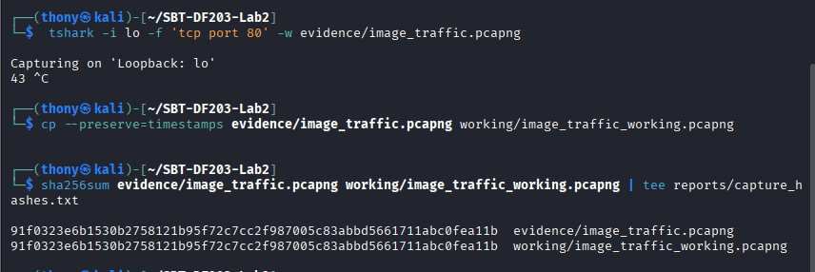
PART B2: Confirm that image.html displays both text and the embedded image.
View of webpage using http://127.0.0.1/image.html incognito browser
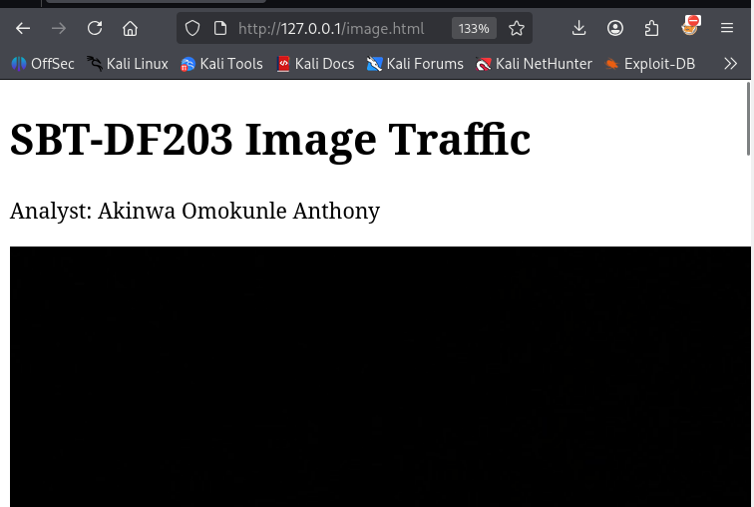
File type | Dimension and size | Source of image
JPEG | 5184x3888 | lab_photo.jpg

Part C
Prove That Two Objects Were Requested
Part C1: Flilter HTTP request
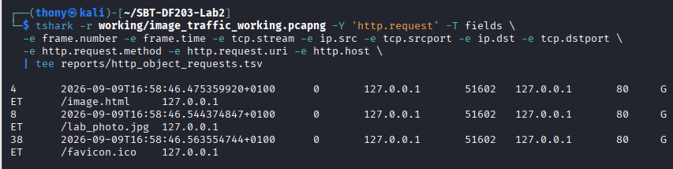
HTTP Request:
Field | Vaule
Method | GET
URL | /image.html
Host | 127.0.0.1
Accept | */*

Part C2: Filter for HTTP Response
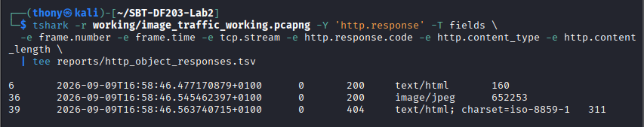
Field | Vaule
Status code | 200
Response code | OK
Content_type | image/jpeg
Content_lenght | 652253
Date | 2026-09-09T16:58:46

Part D
Analyze TCP Segmentation and Reassembly
Part D1: Select the HTTP response associated with the image request and note Reassembled TCP Segments.
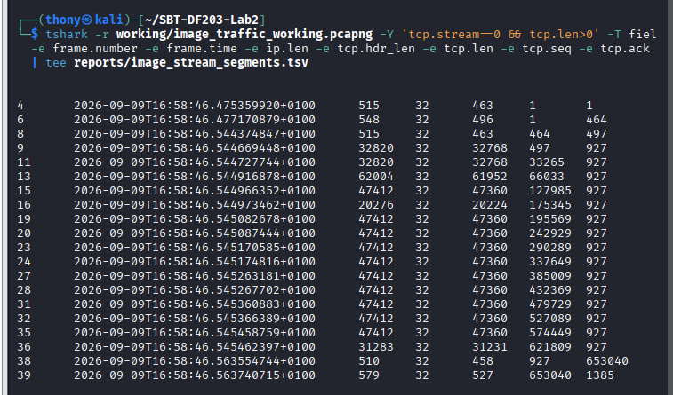
Part D2: Record the number and tcp.len value of each contributing segment.
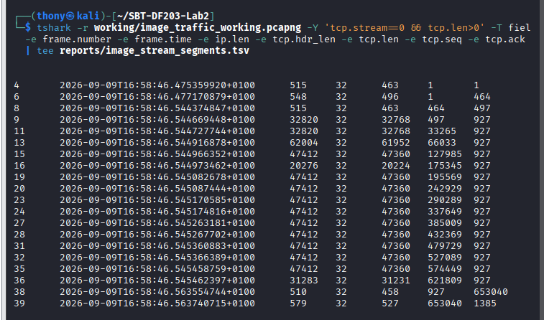

Part D3: Add the TCP payload lengths and compare the result with the HTTP header plus object data.
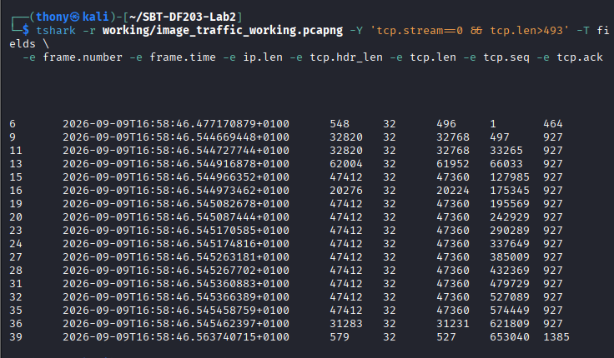

Part E
Export the Embedded Image

StepE1:
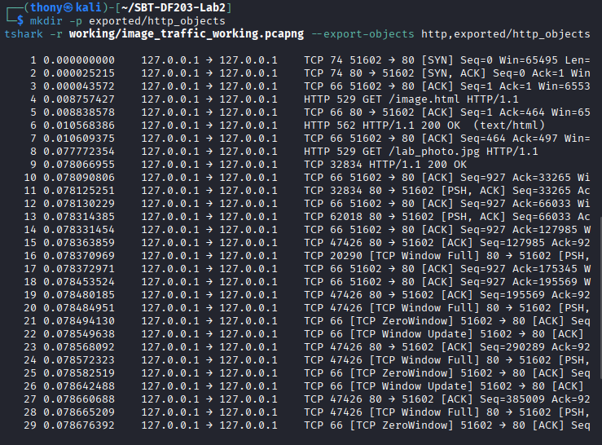
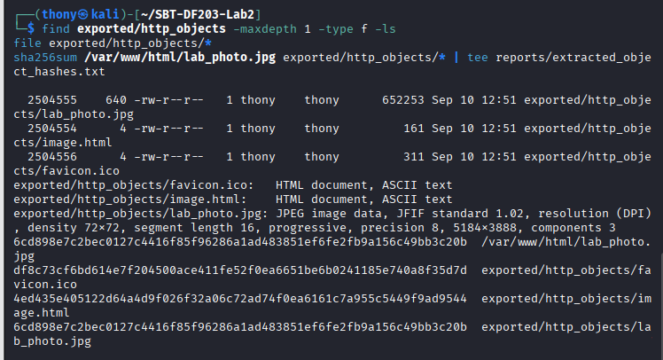

Part F
Compare curl and Browser Behaviour
sudo tshark -i lo -f 'tcp port 80' -a duration:20 -w evidence/curl_only.pcapng &
sleep 2
curl -v http://127.0.0.1/image.html -o /tmp/image_page.html
wait
tshark -r evidence/curl_only.pcapng -Y 'http.request' -T fields -e http.request.uri | tee reports/curl_requested_objects.txt

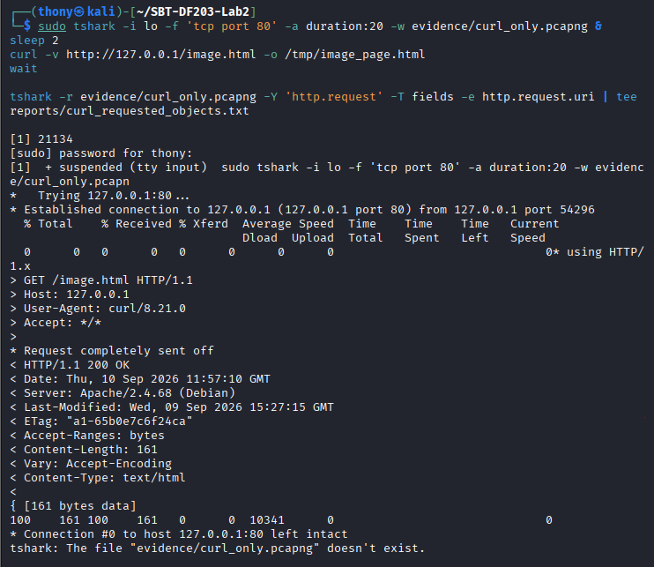

Required Forensic Findings
Finding | Student Observation
Number of HTTP requests | 1
HTML request URI and timestamp | 11:57:10 GMT
Image request URI and timestamp | GET /image.html HTTP/1.1
HTTP response codes | HTTP/1.1 200 OK
Image content type | Text/html
Reported Content-Length | 161
Number of reassembled TCP segments | 43
Sum of TCP payload lengths | 26
Original image SHA-256 | 6cd898e7c2bec0127c4416f85f96286a1ad483851ef6fe2fb9a156c49bb3c20b
Extracted image SHA-256 | 6cd898e7c2bec0127c4416f85f96286a1ad483851ef6fe2fb9a156c49bb3c20b
Hash comparison conclusion | They are comparison is the same
curl/browser difference | Yes, because the curl retrieves only the explicitly requested URL.

SCREENSHOT AND METHODLOGY
In this assignment we are going to solved it by exercises and everything is answer in methodology:

ANALYSIS AND FINDINGS
During my working on this project, I was able to gain real hands-on experience on how captured traffic was analysed at the HTTP and TCP levels. The HTTP request analysis showed that a single webpage can result in multiple HTTP requests because the browser requests the HTML document and then separately requests the embedded image.
TCP analysis was used to identify the segments responsible for transferring the image. The tcp.len values were examined to understand the amount of application data carried by each TCP segment, while TCP sequence numbers were used to understand how the segments formed part of the complete HTTP response.
The image was then extracted from the captured traffic using Wireshark's Export Objects → HTTP function or TShark's HTTP object export capability. The extracted object was examined and compared with the original source image.
SHA-256 hashes were used as an integrity check. Matching hashes would demonstrate that the extracted image is byte-for-byte identical to the original source image
Findings
The investigation produced the following key findings:
- The webpage and embedded image generated separate HTTP requests.
- HTTP response packets provided useful information such as response codes, content type and content length.
- The image response was transferred through TCP and could span multiple TCP segments.
- TCP sequence numbers and payload lengths helped establish how the image data was transmitted and reassembled.
- The embedded image could be recovered directly from the HTTP packet capture.
- The recovered image could be examined independently using file and image-analysis utilities.
- SHA-256 hashing provided a reliable method for comparing the original and extracted image.
- Browser traffic differs from a basic cURL request because the browser automatically processes the HTML and requests embedded resources, whereas cURL normally retrieves only the explicitly requested URL
The original source image/device was not intentionally modified during forensic acquisition. The acquired image was stored separately from the source and used for subsequent examination.

CHALLENGES AND SOLUTIONS
In this chapter when working on my project, I experienced a challenge of starting what to do at first but at the end of the assignment I was able to solve and have much better experience in understanding it.

CONCLUSION
In this chapter, I was able to gain hand on experienced in understanding how to analyze embedded image traffic using Wireshark and TShark. Thanks to ICDFA, I was able to practically demonstrated how network forensic analysts can identify multiple HTTP requests, analyze TCP segmentation and reassembly, recover transferred objects, and verify recovered evidence using cryptographic hashing.
The exercise also demonstrated the forensic importance of plaintext HTTP traffic because both the webpage and embedded resources can potentially be reconstructed directly from a packet capture. The use of SHA-256 provided an additional integrity check for the original and recovered image, supporting a repeatable and reliable forensic workflow.
These repeatable steps are useful in digital forensic which are also needed for any cybersecurity professional and vulnerable environments.

